**WITH NOISE AND WITH FILTER**

**Image set:**

|  |
| --- |
| **Image 1:-0.1 % Noise** |

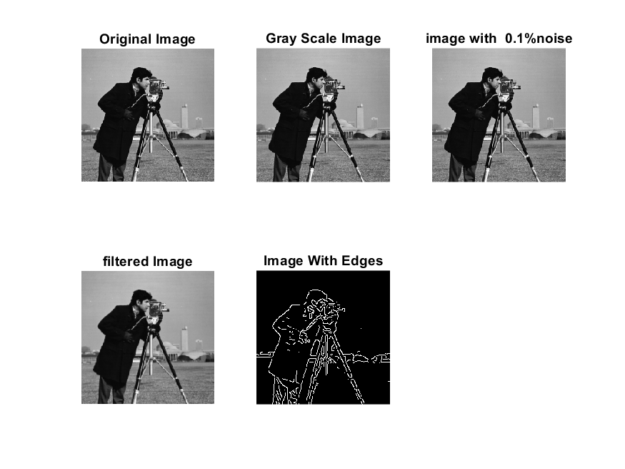

**Image 2:-10 % Noise**

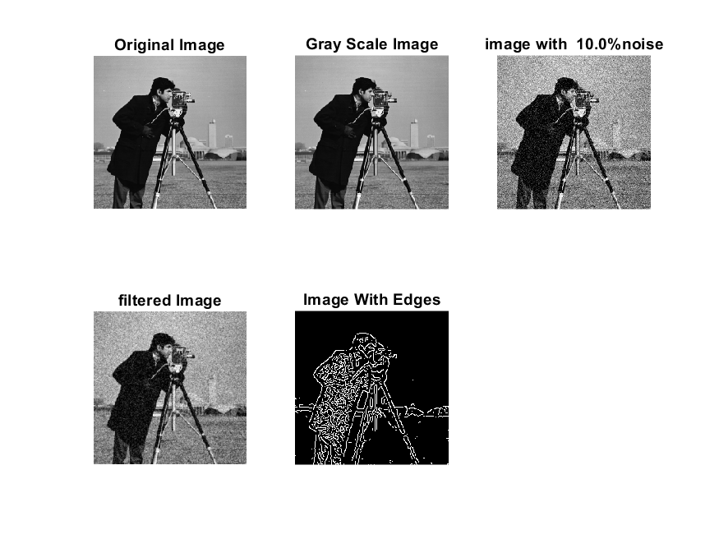

**Image 3:-20 % Noise**

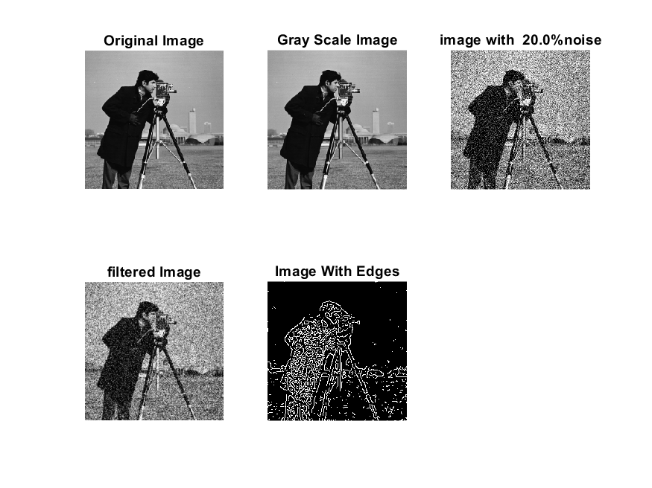

**Image 4:-30 % Noise**

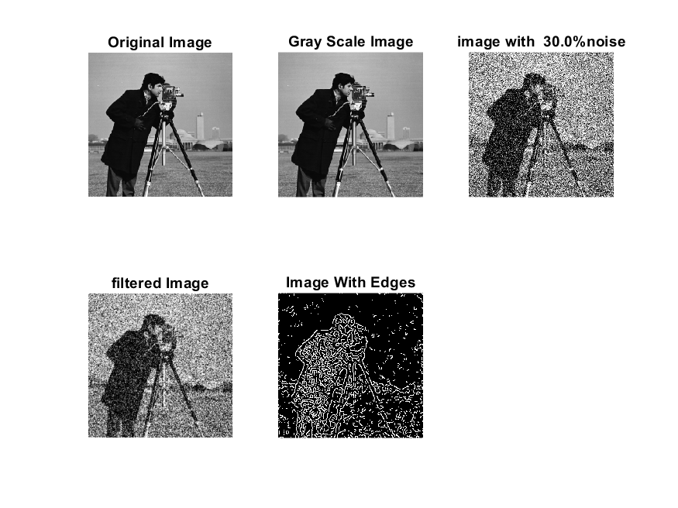

|  |
| --- |
| **Image 5:-40 % Noise** |

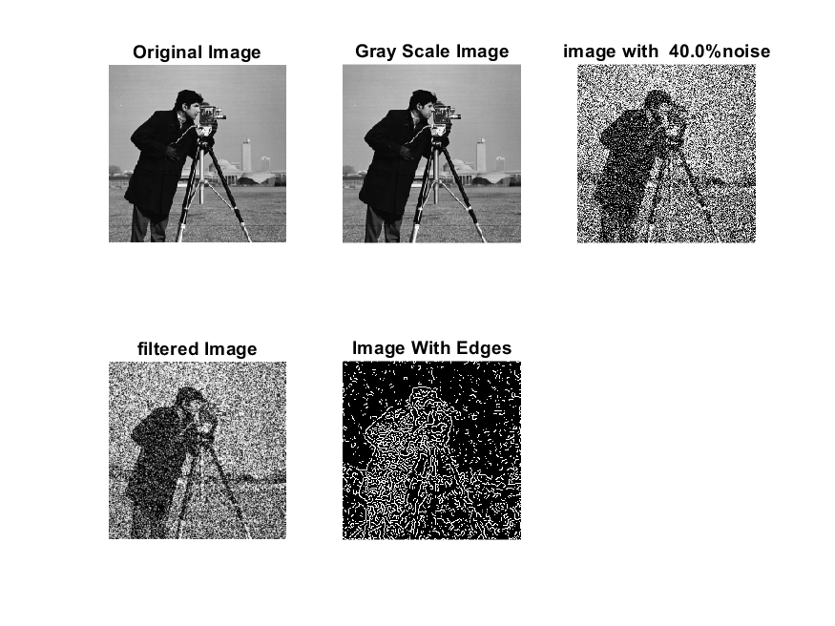

**Image 6:-50 % Noise**

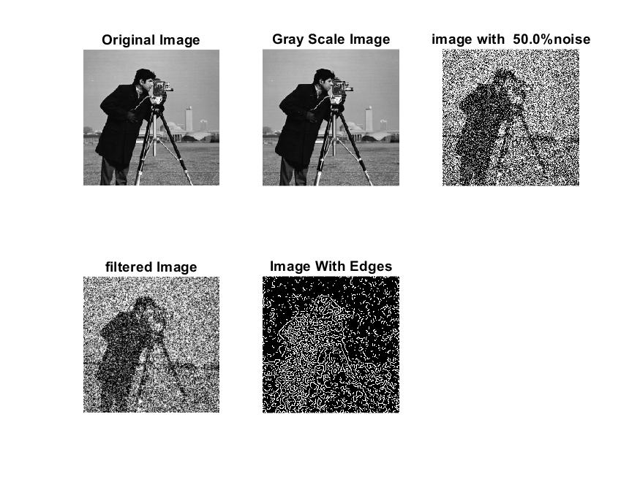

**Image 7:-60 % Noise**

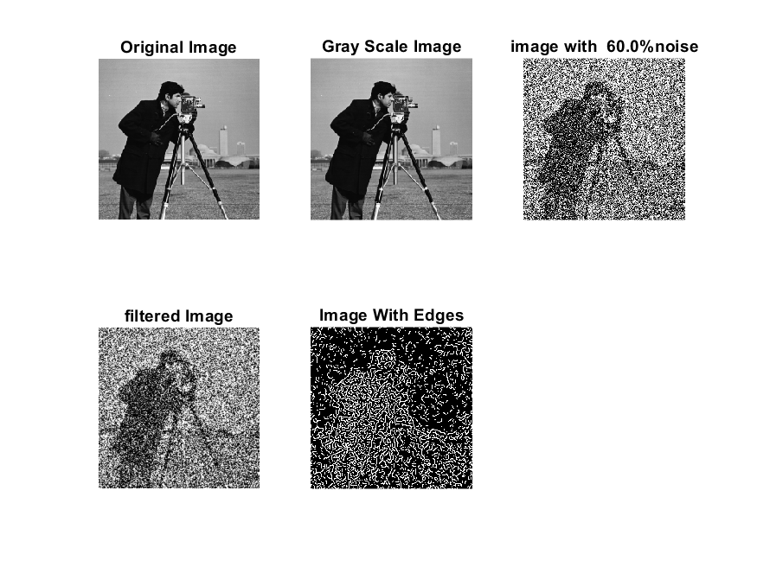

**Image 8:-70 % Noise**

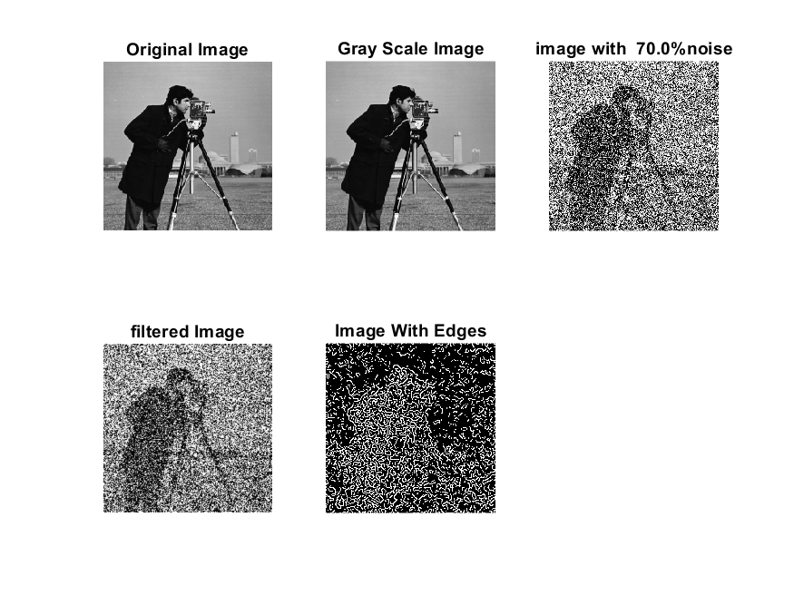

**Image 9:-80 % Noise**

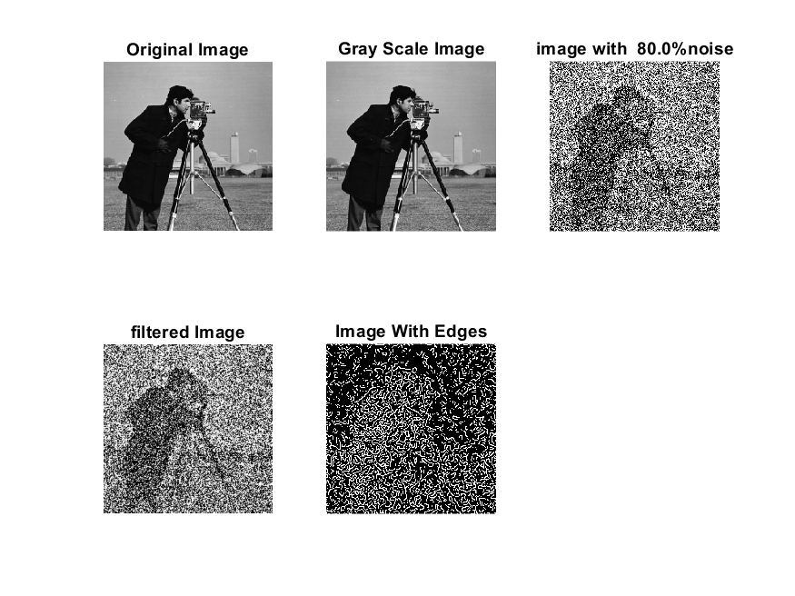

**DATA FILES**

**Image 1:-Noise0.1**

Original image ideal values:

IM1 image entropy:3.197367e-01

IM1 image mean:0.058070

Ground truth image entropy:0.717315

Ground truth image mean:0.197705

entropy between imt and im1 :0.673060

MSE between imt and im1 :0.213995

Average Difference between imt and im1 :0.139635

Maximum Difference between imt and im1 :1.000000

True Positive values:1067.000000

False Positive values: 1899.000000

True Negative values:39079.000000

False Negative values:9031.000000

Accuracy value: 0.786005

F Measure values:0.163350

Peak Signal-to Noise Ration value: 6.695967

Signal-to Noise Ration value: -5.320642

percentage of pixels that were correctly detected (Pco): 0.105664

The percentage of pixels that were not detected (Pnd):0.894336

the percentage of false alarm: (Pfa):0.188057

Euclidean Distance Value :9.651564

**Image 2:-Noise10**

Original image ideal values:

IM1 image entropy:4.639107e-01

IM1 image mean:0.098402

Ground truth image entropy:0.717315

Ground truth image mean:0.197705

entropy between imt and im1 :0.669222

MSE between imt and im1 :0.250881

Average Difference between imt and im1 :0.099303

Maximum Difference between imt and im1 :1.000000

True Positive values:1155.000000

False Positive values: 3871.000000

True Negative values:37107.000000

False Negative values:8943.000000

Accuracy value: 0.749119

F Measure values:0.152737

Peak Signal-to Noise Ration value: 6.005322

Signal-to Noise Ration value: -3.030129

percentage of pixels that were correctly detected (Pco): 0.114379

The percentage of pixels that were not detected (Pnd):0.885621

the percentage of false alarm: (Pfa):0.383343

Euclidean Distance Value :10.519805

**Image 3:-Noise20**

Original image ideal values:

IM1 image entropy:5.216514e-01

IM1 image mean:0.117335

Ground truth image entropy:0.717315

Ground truth image mean:0.197705

entropy between imt and im1 :0.655914

MSE between imt and im1 :0.258066

Average Difference between imt and im1 :0.080370

Maximum Difference between imt and im1 :1.000000

True Positive values:1455.000000

False Positive values: 4538.000000

True Negative values:36440.000000

False Negative values:8643.000000

Accuracy value: 0.741934

F Measure values:0.180846

Peak Signal-to Noise Ration value: 5.882685

Signal-to Noise Ration value: -2.265911

percentage of pixels that were correctly detected (Pco): 0.144088

The percentage of pixels that were not detected (Pnd):0.855912

the percentage of false alarm: (Pfa):0.449396

Euclidean Distance Value :13.472148

**Image 4:-Noise30**

Original image ideal values:

IM1 image entropy:6.047014e-01

IM1 image mean:0.147956

Ground truth image entropy:0.717315

Ground truth image mean:0.197705

entropy between imt and im1 :0.638733

MSE between imt and im1 :0.273964

Average Difference between imt and im1 :0.049749

Maximum Difference between imt and im1 :1.000000

True Positive values:1831.000000

False Positive values: 5726.000000

True Negative values:35252.000000

False Negative values:8267.000000

Accuracy value: 0.726036

F Measure values:0.207420

Peak Signal-to Noise Ration value: 5.623060

Signal-to Noise Ration value: -1.258859

percentage of pixels that were correctly detected (Pco): 0.181323

The percentage of pixels that were not detected (Pnd):0.818677

the percentage of false alarm: (Pfa):0.567043

Euclidean Distance Value :17.184538

**Image 5:-Noise40**

Original image ideal values:

IM1 image entropy:6.822702e-01

IM1 image mean:0.181005

Ground truth image entropy:0.717315

Ground truth image mean:0.197705

entropy between imt and im1 :0.626612

MSE between imt and im1 :0.296910

Average Difference between imt and im1 :0.016701

Maximum Difference between imt and im1 :1.000000

True Positive values:2089.000000

False Positive values: 7156.000000

True Negative values:33822.000000

False Negative values:8009.000000

Accuracy value: 0.703090

F Measure values:0.215995

Peak Signal-to Noise Ration value: 5.273745

Signal-to Noise Ration value: -0.383285

percentage of pixels that were correctly detected (Pco): 0.206873

The percentage of pixels that were not detected (Pnd):0.793127

the percentage of false alarm: (Pfa):0.708655

Euclidean Distance Value :19.738978

**Image 6:-Noise50**

Original image ideal values:

IM1 image entropy:7.319470e-01

IM1 image mean:0.205067

Ground truth image entropy:0.717315

Ground truth image mean:0.197705

entropy between imt and im1 :0.614456

MSE between imt and im1 :0.311066

Average Difference between imt and im1 :-0.007362

Maximum Difference between imt and im1 :1.000000

True Positive values:2342.000000

False Positive values: 8132.000000

True Negative values:32846.000000

False Negative values:7756.000000

Accuracy value: 0.688934

F Measure values:0.227688

Peak Signal-to Noise Ration value: 5.071476

Signal-to Noise Ration value: 0.158772

percentage of pixels that were correctly detected (Pco): 0.223601

The percentage of pixels that were not detected (Pnd):0.740500

the percentage of false alarm: (Pfa):0.776399

Euclidean Distance Value :21.407953

**Image 7:-Noise60**

Original image ideal values:

IM1 image entropy:7.671578e-01

IM1 image mean:0.223862

Ground truth image entropy:0.717315

Ground truth image mean:0.197705

entropy between imt and im1 :0.603117

MSE between imt and im1 :0.320816

Average Difference between imt and im1 :-0.026157

Maximum Difference between imt and im1 :1.000000

True Positive values:2573.000000

False Positive values: 8861.000000

True Negative values:32117.000000

False Negative values:7525.000000

Accuracy value: 0.679184

F Measure values:0.238993

Peak Signal-to Noise Ration value: 4.937439

Signal-to Noise Ration value: 0.539628

percentage of pixels that were correctly detected (Pco): 0.225031

The percentage of pixels that were not detected (Pnd):0.658125

the percentage of false alarm: (Pfa):0.774969

Euclidean Distance Value :21.545624

**Image 8:-Noise70**

Original image ideal values:

IM1 image entropy:7.885592e-01

IM1 image mean:0.236138

Ground truth image entropy:0.717315

Ground truth image mean:0.197705

entropy between imt and im1 :0.594773

MSE between imt and im1 :0.326553

Average Difference between imt and im1 :-0.038433

Maximum Difference between imt and im1 :1.000000

True Positive values:2740.000000

False Positive values: 9321.000000

True Negative values:31657.000000

False Negative values:7358.000000

Accuracy value: 0.673447

F Measure values:0.247304

Peak Signal-to Noise Ration value: 4.860469

Signal-to Noise Ration value: 0.771480

percentage of pixels that were correctly detected (Pco): 0.227179

The percentage of pixels that were not detected (Pnd):0.610066

the percentage of false alarm: (Pfa):0.772821

Euclidean Distance Value :21.759803

**Image 9:-Noise80**

Original image ideal values:

IM1 image entropy:8.100968e-01

IM1 image mean:0.249256

Ground truth image entropy:0.717315

Ground truth image mean:0.197705

entropy between imt and im1 :0.593564

MSE between imt and im1 :0.338731

Average Difference between imt and im1 :-0.051551

Maximum Difference between imt and im1 :1.000000

True Positive values:2764.000000

False Positive values: 9967.000000

True Negative values:31011.000000

False Negative values:7334.000000

Accuracy value: 0.661269

F Measure values:0.242148

Peak Signal-to Noise Ration value: 4.701457

Signal-to Noise Ration value: 1.006272

percentage of pixels that were correctly detected (Pco): 0.217108

The percentage of pixels that were not detected (Pnd):0.576074

the percentage of false alarm: (Pfa):0.782892

Euclidean Distance Value :20.753957